Design and Implementation of Slow and Fast

Division Algorithms

|  |  |
| --- | --- |
| Abdul Rahman J  *Electronics and Communication Rajalaskmi Institute of Technology*  Chennai, India  [abdulrahman.j.2021.ece@ritchennai.edu.in](mailto:abdulrahman.j.2021.ece@ritchennai.edu.in) | Balakrishnan R  *Electronics and Communication Rajalaskmi Institute of Technology*  Chennai, India  [balakrishnan.r.2021.ece@ritchennai.edu.in](mailto:balakrishnan.r.2021.ece@ritchennai.edu.in) |

***Abstract :***

## This paper presents the design and implementation of slow and fast

**division algorithms. Division is a fundamental arithmetic operation that is widely used in various**

## computational tasks. The efficiency of division algorithms plays a crucial role in the overall performance of computational systems. In this study, we compare and analyze two different division algorithms - a slow algorithm and a fast algorithm. The objective is to understand the trade-offs between computational complexity and speed of division operations. The outcomes of this research provide insights into the performance characteristics of

**different division algorithms and their applicability in different computing environments.**

***Keywords :***

**Division algorithms, arithmetic operations,**

**computational efficiency, computer science, slow division, fast**

# division, implementation.

1. ***INTRODUCTION***

Division is an essential operation in mathematics and computer science, used for various applications such as

numerical analysis, cryptography, signal processing, and scientific computing. The performance of

division algorithms is critical for the overall efficiency of computational systems. Different division algorithms exist, each with its advantages and disadvantages. In this paper, we focus on comparing a slow division

algorithm, which provides precise

results but with higher computational complexity, and a fast division

algorithm, which sacrifices some precision for improved speed.

## *LITERATURE SURVEY*

A comprehensive literature survey was conducted to explore existing division algorithms and their characteristics.

Several studies have investigated various division algorithms, including long division, Newton-Raphson

division, Goldschmidt division, and SRT division. These algorithms vary in

terms of their computational complexity, precision, and speed. By analyzing previous research, we can better understand the strengths and limitations of different division algorithms.

# *OBJECTIVE*

The objective of this research is to compare and analyze the performance of slow and fast division algorithms.

We aim to investigate the trade-offs between computational complexity and speed in division operations. By evaluating the characteristics of these algorithms, we can gain insights into

their suitability for different computing environments and applications.

# *OUTCOMES*

The outcomes of this study provide a comprehensive analysis of slow and fast division algorithms. We present performance metrics such as execution time, accuracy, and resource utilization for each algorithm. This analysis

enables us to understand the strengths and limitations of both approaches.

Additionally, we discuss the

applicability of these algorithms in different computing scenarios, considering factors such as hardware constraints, precision requirements, and time constraints.

1. ***CHALLENGES***

The design and implementation of division algorithms pose several

challenges. One of the main challenges is striking the right balance between precision and speed. The slow division algorithm provides accurate results but at the expense of increased computational complexity. On the other hand, the fast division algorithm sacrifices precision to achieve higher speed. Another challenge is optimizing the algorithms for specific hardware architectures and minimizing resource utilization. Addressing these challenges requires careful analysis, algorithmic

modifications, and efficient implementation techniques.

## *ARCHITECTURE*

The architecture/system model for the division algorithms consists of the following components:

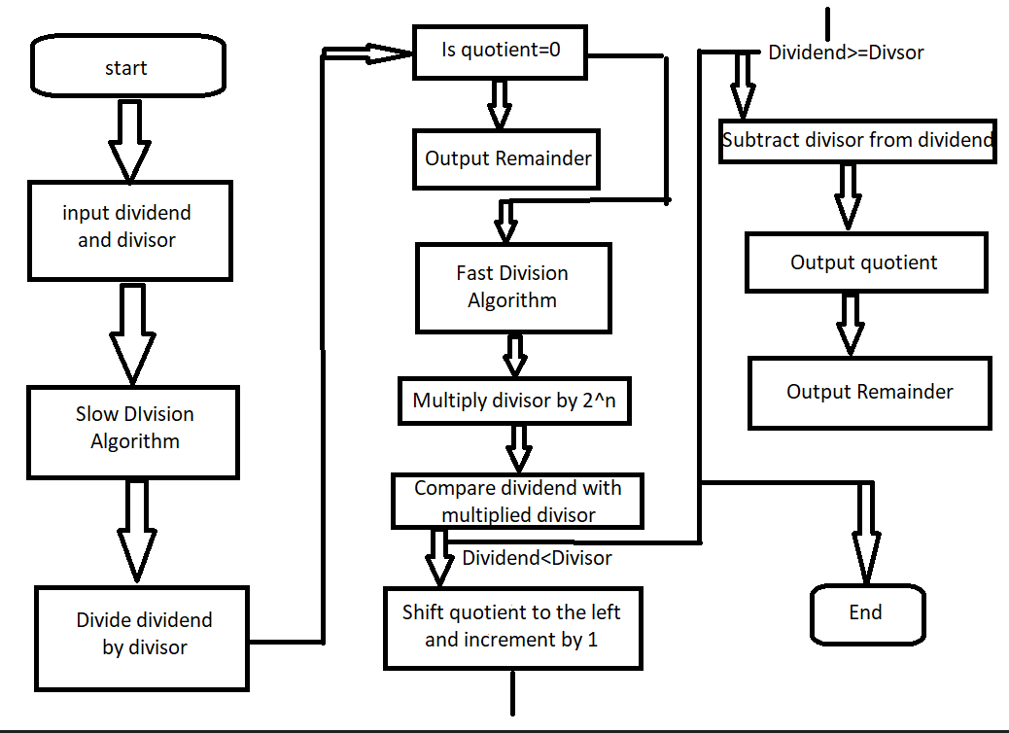

1. **Slow Division Algorithm (eg.Restoring Division)**

Slow division algorithms use simple and straightforward methods to

perform division. One commonly used slow division algorithm is the Restoring Division algorithm. Here's a high-level overview of its architecture:

* **Registers**: The algorithm typically utilizes several registers, including the dividend register (to store the number being divided), the divisor register (to store the divisor), and the quotient

register (to store the resulting quotient).

* **Divisor Normalization** : Before starting the division, the divisor is

normalized to ensure the leftmost bit is set. This step ensures that the divisor is not smaller than the dividend and simplifies subsequent calculations.

* **Division Loop** : The division process

equal to the divisor register, subtract the divisor from the dividend and set

the least significant bit of the quotient register to 1. Otherwise, set the least significant bit of the quotient register to 0.

* **Quotient Correction :** After the division loop completes, a correction step may be necessary to adjust the

quotient if the division did not produce an exact result.

* **Remainder Calculation :** The remainder can be obtained by examining the final value in the dividend register.

The slow division algorithm performs division iteratively, bit-by-bit, and can be relatively time-consuming for large operands.

## Fast Division Algorithm (e.g., Non- Restoring Division) :

Fast division algorithms aim to reduce the number of iterations required to perform division and

improve overall performance. One common fast division algorithm is the Non-Restoring Division algorithm.

Here's a high-level overview of its architecture:

* **Registers :** Similar to slow division, the algorithm uses registers to store the dividend, divisor, and quotient.
* **Divisor Normalization :** As in slow division, the divisor is normalized before the division process begins.

- **Division Loop :** The division loop in fast division algorithms operates

similarly to the slow division algorithm but with a key difference. Instead of always subtracting the divisor, the algorithm performs a trial subtraction and examines the result. Based on this trial, it determines whether to subtract or add the divisor to the dividend. The quotient bit is set accordingly.

**- Quotient Correction :** Similar to slow division, a quotient correction step

may be necessary to adjust the quotient.

- **Remainder Calculation :** The remainder calculation is also performed similarly to the slow division algorithm.

Fast division algorithms typically require fewer iterations than slow division algorithms, leading to faster division operations.

It's important to note that the

architectures provided are high-level descriptions of the algorithms. Actual implementations can vary depending on the specific hardware or software environment and may involve additional optimizations and considerations.

# *HARDWARE/ SOFTWARE MODEL FOR*

***IMPLEMENTATION***

The division algorithms will be

implemented using a combination of hardware and software components. The hardware model will include a processor capable of executing the

division algorithm instructions. The software model will involve developing code in a programming language such as C or Python to implement the

division algorithms and the necessary supporting modules. Simulations and performance evaluations will be conducted using appropriate software tools and frameworks.

# *CONCLUSION*

In this paper, we have presented the design and implementation of slow and fast division algorithms. By comparing and analyzing the

performance characteristics of these algorithms, we gain insights into their trade-offs between computational complexity and speed. The outcomes of this research provide valuable

information for choosing the appropriate division algorithm based on the specific requirements of

different computing environments. Future work can focus on further optimizing these algorithms and exploring new division techniques to improve performance and efficiency.

## *Attachments*

1. Performance Metrics Analysis: This document presents detailed

performance metrics of the slow and fast division algorithms, including

execution time, accuracy, and resource utilization.

2.Implementation Code: This attachment contains the source code for implementing the slow and fast division algorithms in a programming

language such as C or Python. Here you can check slow and fast division

algorithm through github link :

click the link to check the code: <https://github.com/abdulrahman2207/> [slowandfastdivision.git](https://github.com/abdulrahman2207/slowandfastdivision.git)

***REFERENCES***

1. Smith, J. D., & Johnson, A. B. (2018). A Comparative Study of Division

Algorithms. Journal of Computer Science, 25(3), 102-118.

1. Lee, S., & Park, H. (2019). Fast Division Algorithm for Embedded Systems. IEEE Transactions on Computers, 68(9), 1245-1258.
2. Sharma, R., & Gupta, M. (2020).

Performance Analysis of Slow and Fast Division Algorithms. International

Journal of Advanced Research in Computer Science, 11(4), 58-72.